STEPS TO BE FOLLOWED FOR INSTALLING OF OS

Initially before installing the following steps need to be followed: -

- Take all the back up (of MS-Office Files, datatfiles, backupfiles, Sql Backup Files, mdf, ldf, project files) before formatting.
- Check if there are any data kept in c:/Wtsrv/profiles/<UserName>/Personal Folders (for all the users) too.
- Note down the IP Address of the Server.
- Check if Floppy Drive, Tape Drive & CD Drives are connected and working.
- After taking back up restart the system.
- While Restarting the System Press F2 to Go to BIOS setting.
BIOS

BOOT

BOOT DRIVE PRIORITY

REMOVABLE DRIVERS
CDROM

In BIOS Settings change the option to Removable Disk as the OS is installed using Floppy Drives. Save and quit.

Windows 2003
- Installation will start direct from CD and it will ask steps just follow the steps
- Service Pack 2(SP2) need to be installed (if not installed chances of print related problems)
- MS Office
- Kannada Software
- SQL Server 2000>with this SP3A need to be installed
- Visual Basic

Note: Installation must be in the steps mentioned Mainly Kannada software must not be installed after SQL Server 2000
----------------------------------------------------------------------------------------------------------------------------------------------------------------------------------------

NTTSE
- Need of 5 floppy along with CD
- Boot1
- Boot2
- Boot3
- Adaptic SCSI driver
- Network adapter
Note: If any corruption in floppy need to make floppies giving following command C:\i386\>winnt32/OX
Floppies will be created in reverse order (boot3, boot2, boot1)
- Ie6 and sp6
- MS Office
- Kannada Software
- SQL Server 2000-> SP3A not required here
- Visual Basic
- Citrix(VXL)->i386->autorun

8. Citrix Activation.->in boot1 floppy there is ctrixlms exe run that->select the specified and click activate.
--------------------------------------------------------------------------------------------

Check the Connectivity From Thin client
1)Start->Settings->Control Panel->Add or Remove Programs->Add/Remove Windows Components

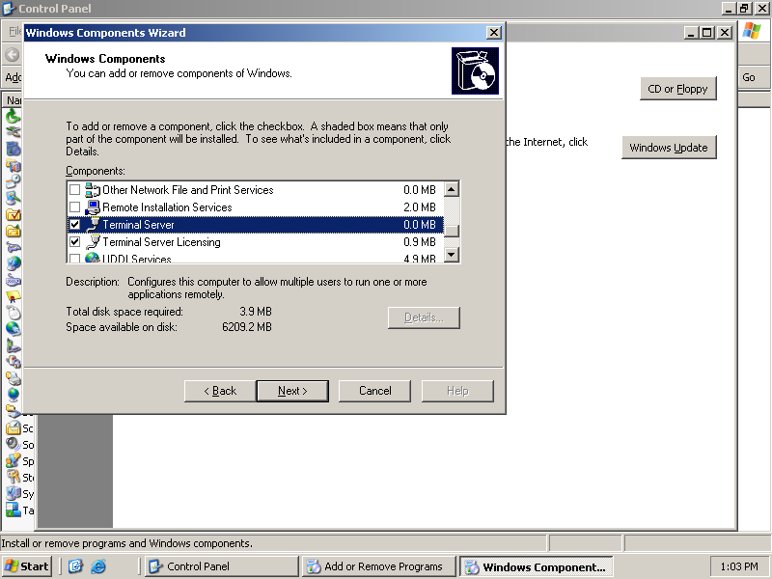

2)

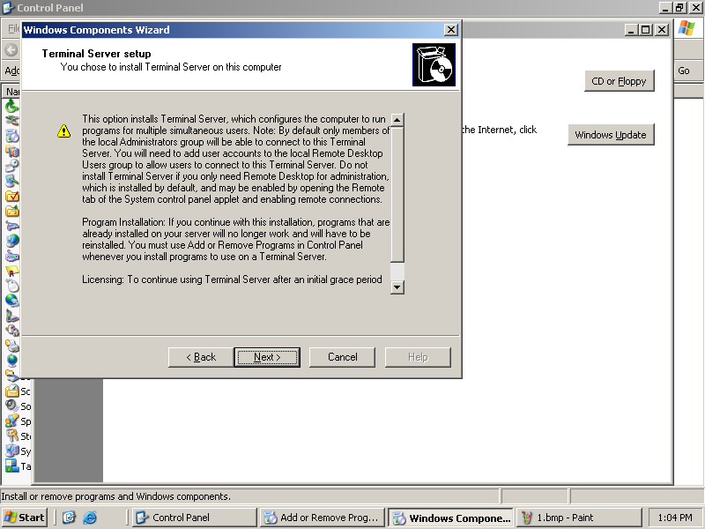

3)

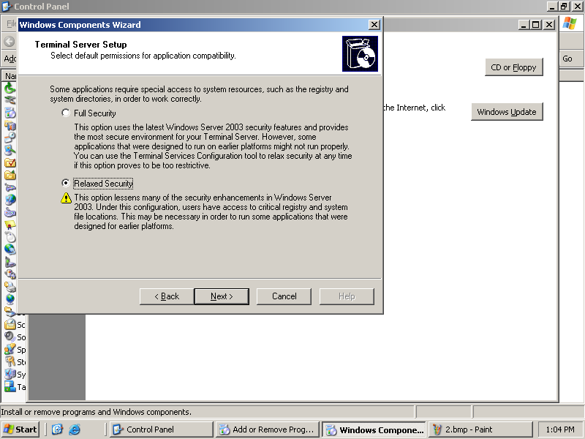

4)

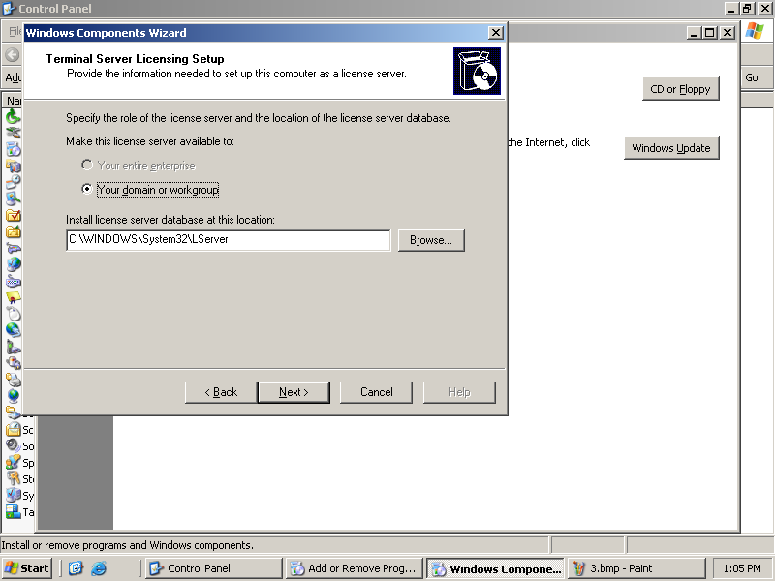

5)

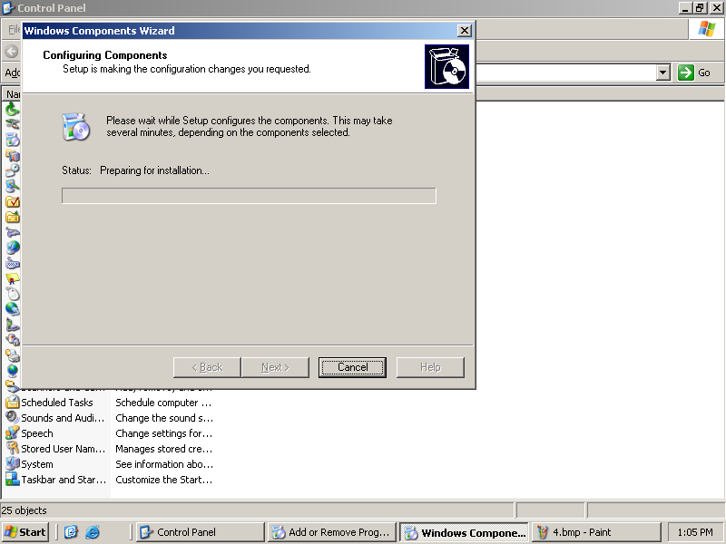

6)

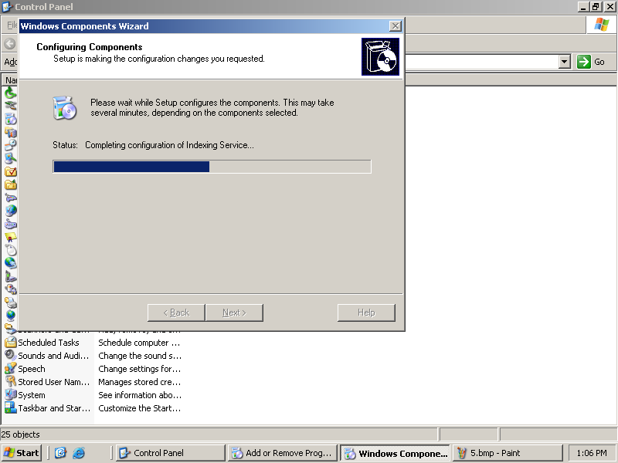

7)

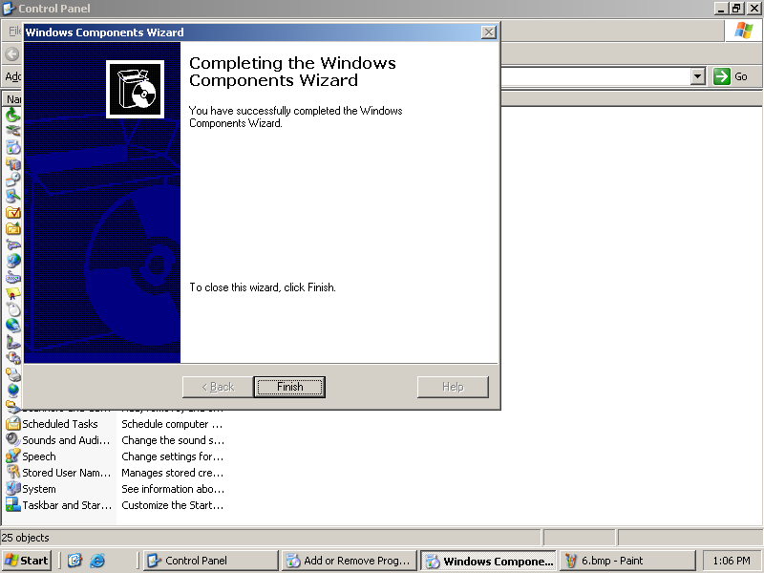

8)

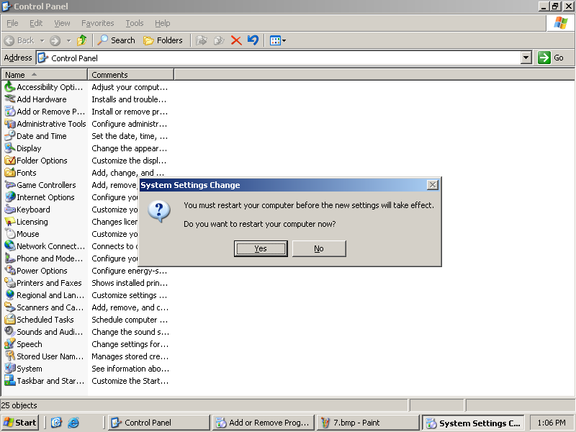

9)

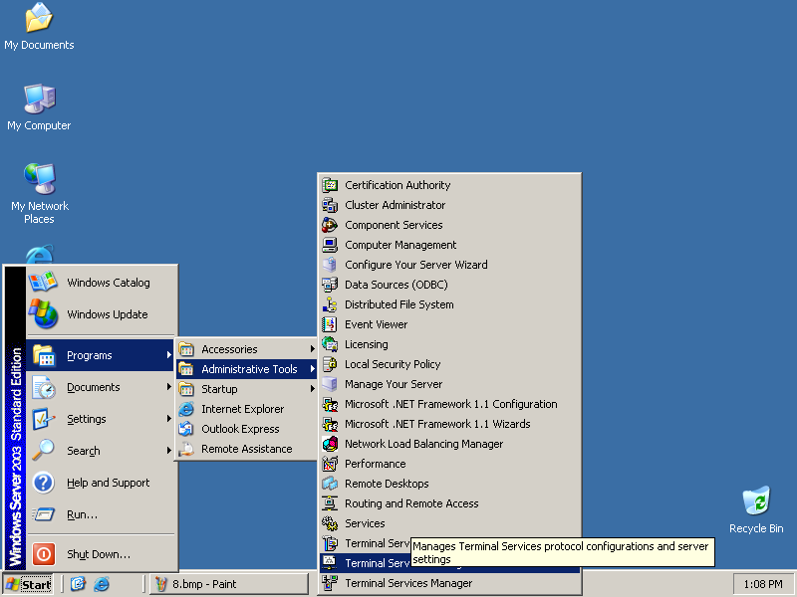

10)

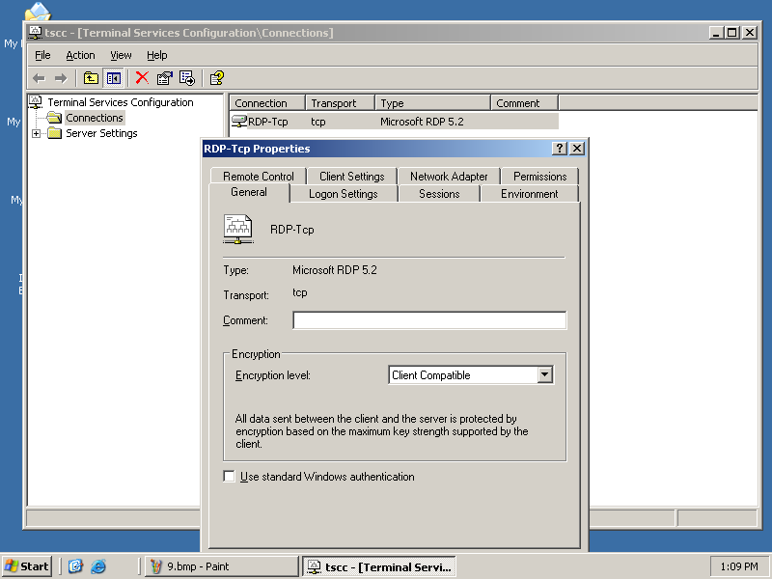

11)

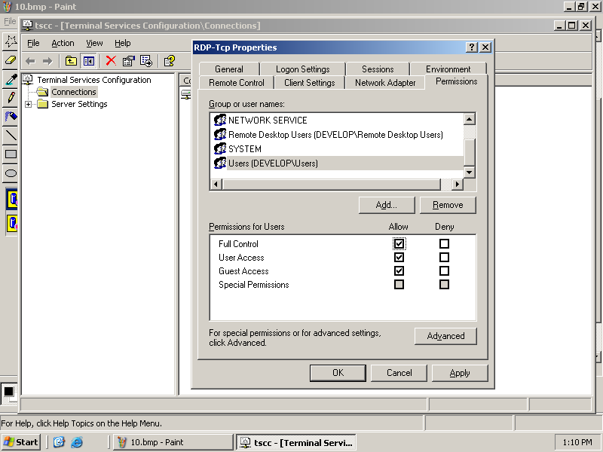

12)

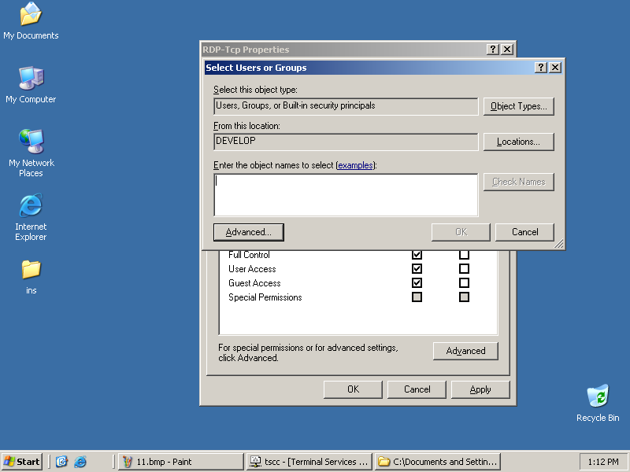

13)

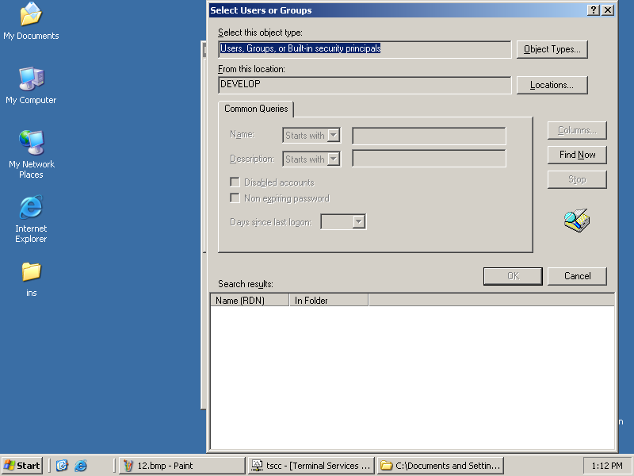

14)

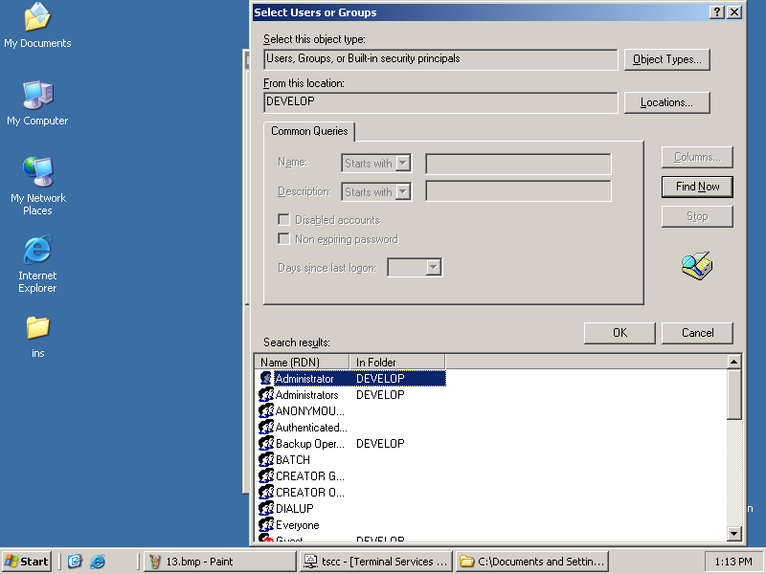

15)

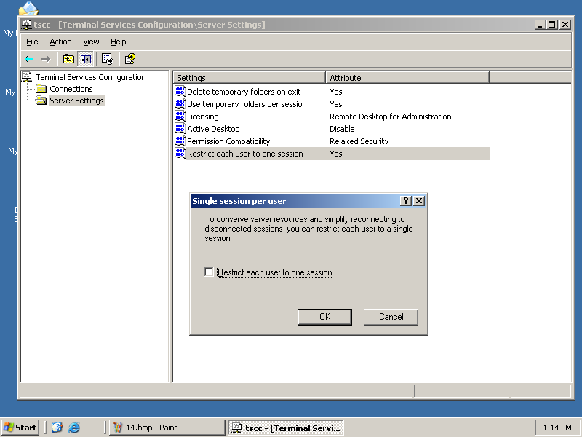

SP2 INSTALLATION
16)

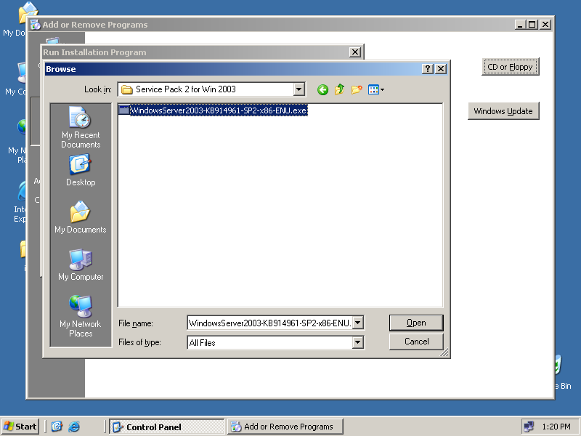

17)
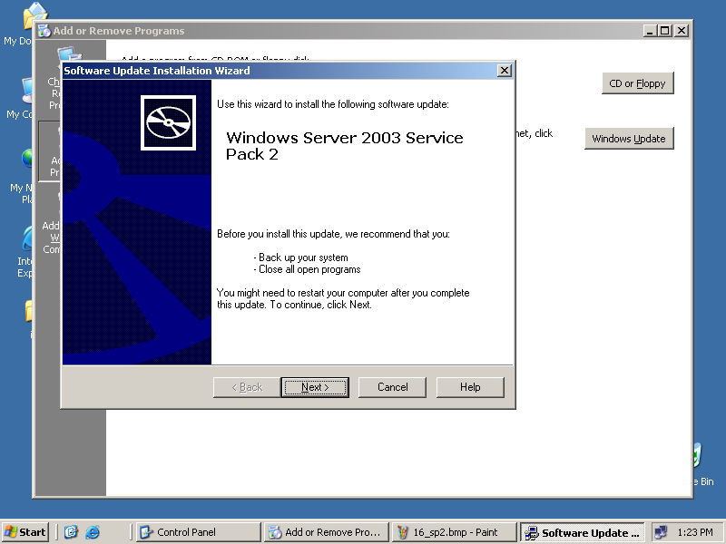

18)

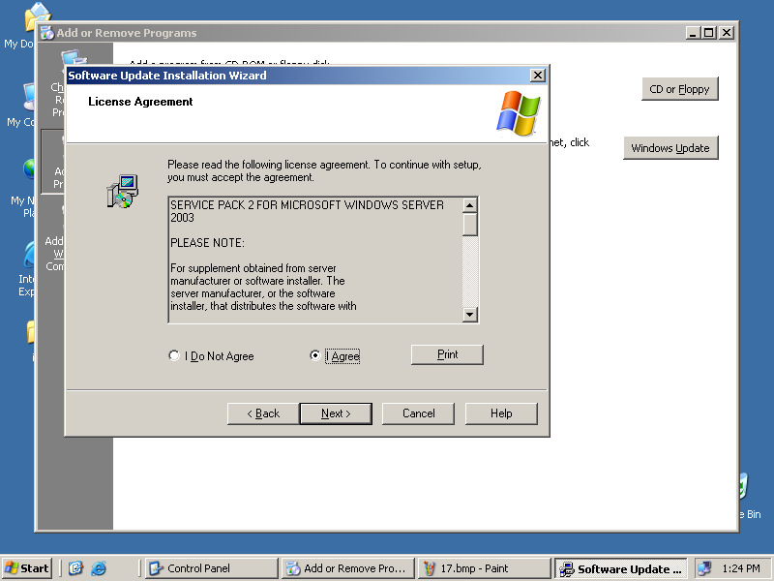

19)

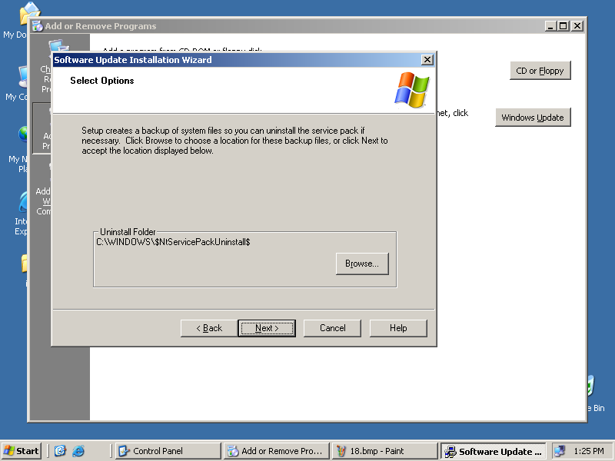

20)

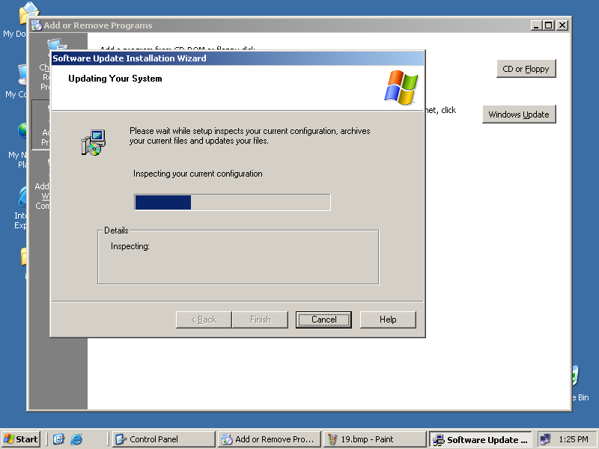

21)

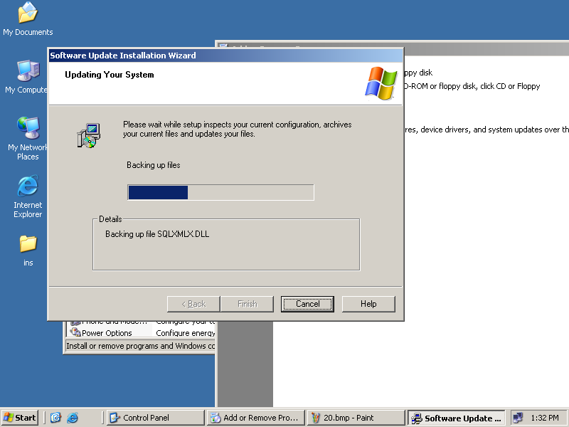

22)

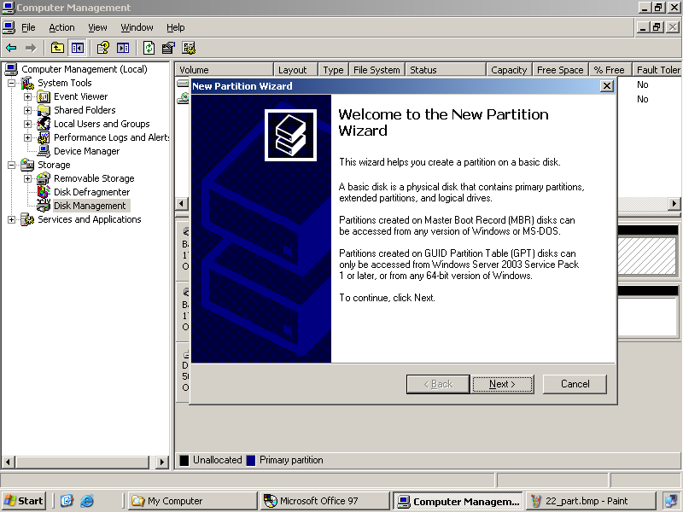

23)

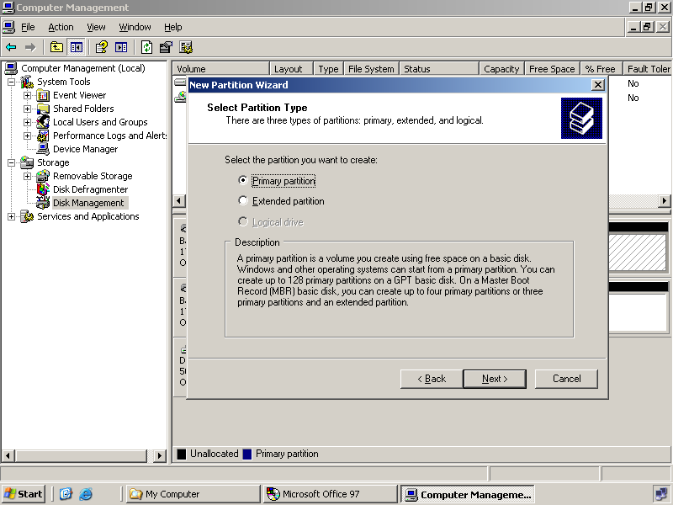

MS OFFICE INSTALLATION

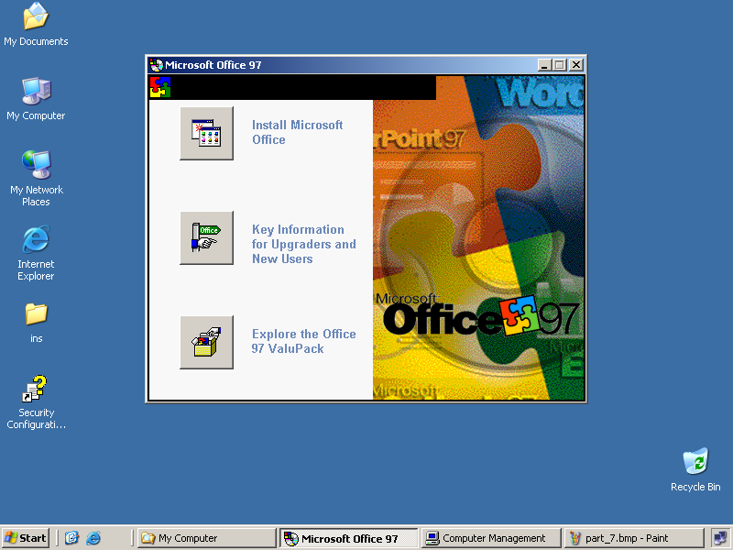

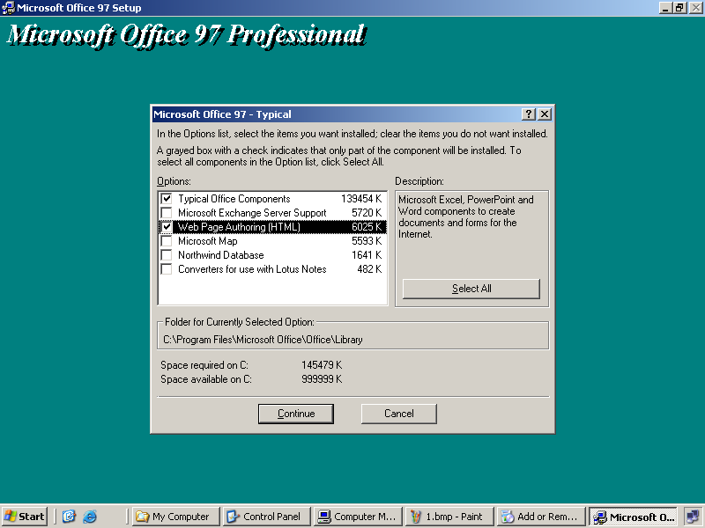

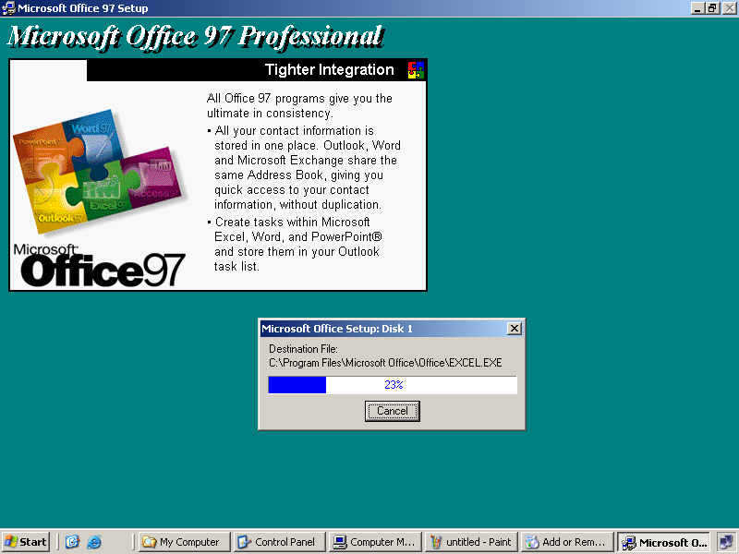

Surabhi(kannada software)
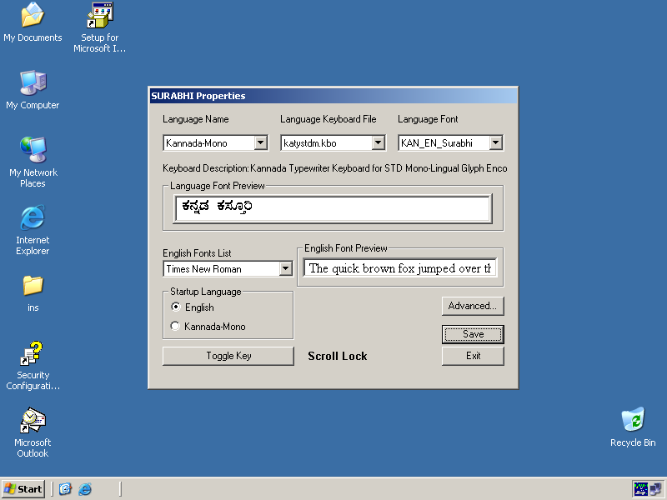

SQL INSTALLATION

Insert the Microsoft SQL Server 2000 compact disc in your CD-ROM drive. If the compact disc does not auto run, double-click Autorun.exe in the root directory of the compact disc as shown below

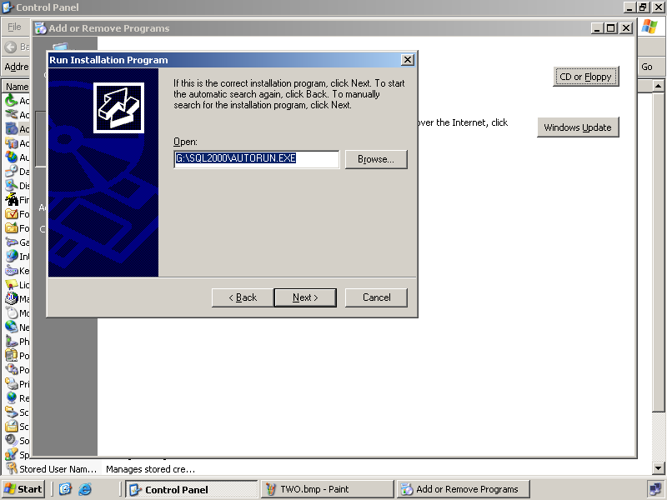

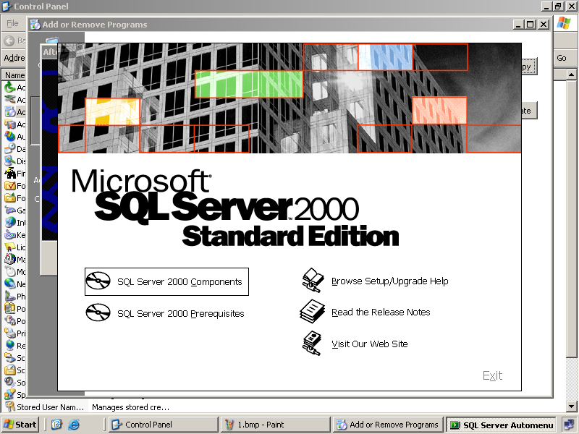
In the above screen Select SQL Server 2000 Components - If you are running Microsoft Windows 95, click SQL Server 2000 Prerequisites, and then click Install Common Controls Library Update

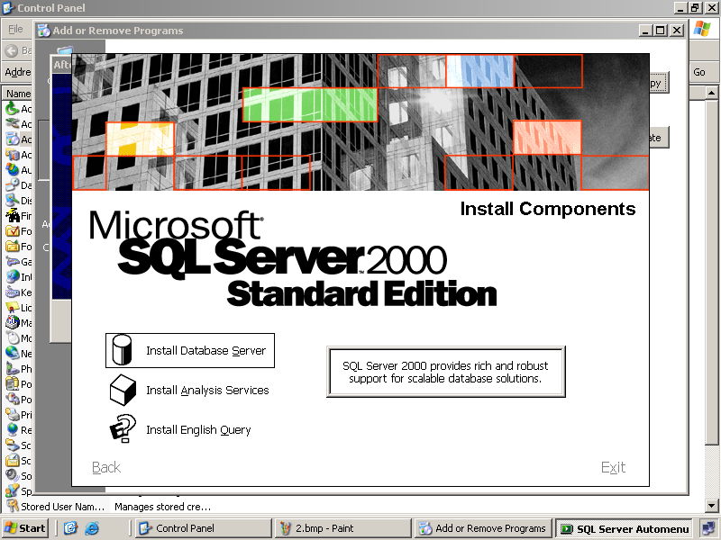

In the above screen select Install Database Server and setup prepares the SQL Server Installation Wizard. At the Welcome screen that appears as shown below, click next.

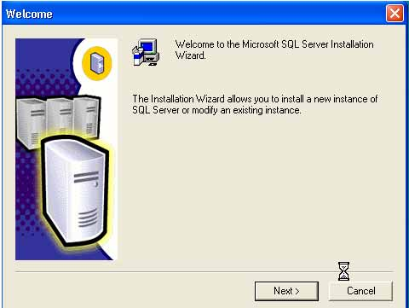

In the Computer Name dialog box, Local Computer is the default option and the local computer name appears in the edit box. Click Next. For a remote SQL Server installation, click Remote Computer. You can then type a computer name or click Browse to locate a remote computer. If a cluster is detected, Virtual server is the default option.
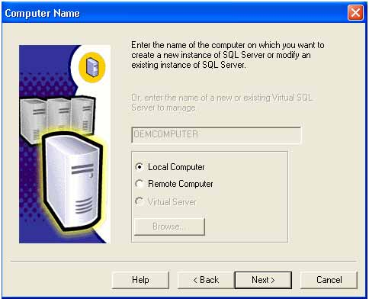

In the Installation Selection dialog box, click Create a new instance of SQL Server, or install Client Tools, and then click Next.
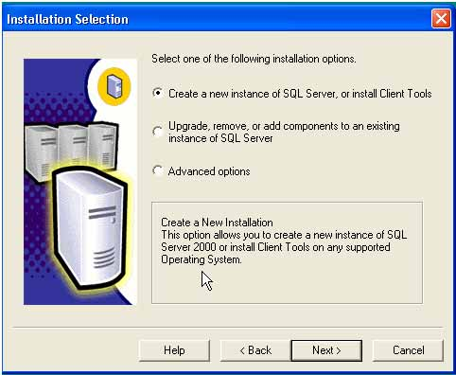

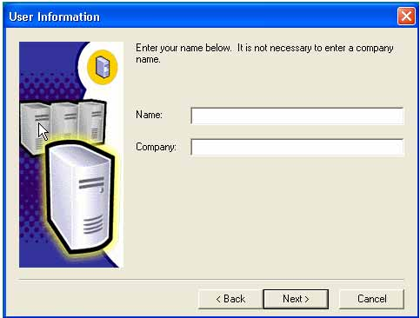

Follow directions on the User Information, Software License Agreement and related screens
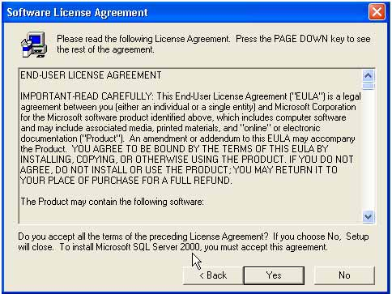

In the Installation Definition dialog box, click Server and Client Tools, and then click Next.
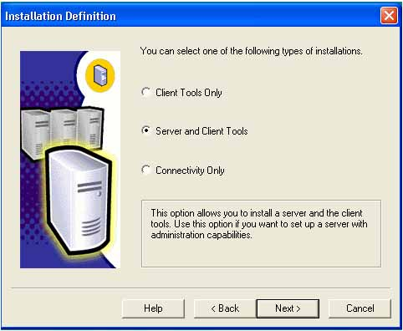

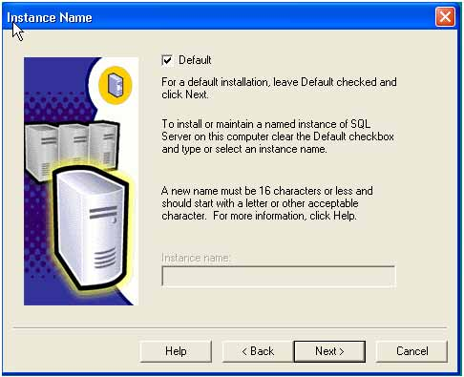
In the Instance Name dialog box, if the Default check box is available, you can install either the default or a named instance.

If the Default check box is not available, a default instance has already been installed, and you can install only a named instance.

To install the default instance, select the Default check box, and click Next.

To install a named instance, clear the Default check box, and type a new named instance in the Instance Name edit box. Click Next.

In the Setup Type dialog box, click Typical or Minimum, and then click Next. If you want to select components and subcomponents, change characters set, network libraries or other settings, click Custom, and then click next.
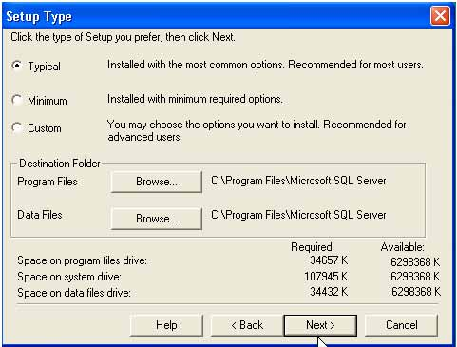

In the Service Accounts dialog box, accept the default settings, enter your domain password, and then click Next.
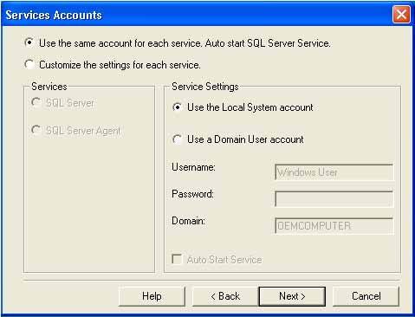

In the Authentication Mode dialog box, select "Mixed Mode"; this will allow users to connect from a non windows environment.
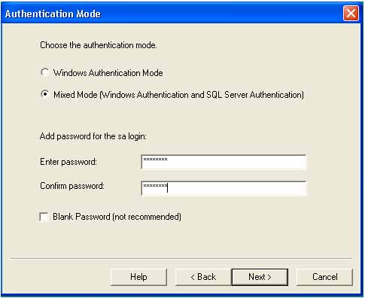

When you are finished specifying options, click Next in the Start Copying Files dialog box.
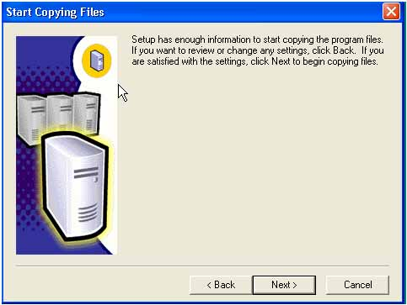
In the Choose Licensing Mode dialog box, make selections according to your license agreement, and click Continue to begin the installation. Click Help for information about licensing or see your system administrator.

In the Setup Complete dialog box, click Yes, I want to restart my computer now, and then click Finish.
VB

1)
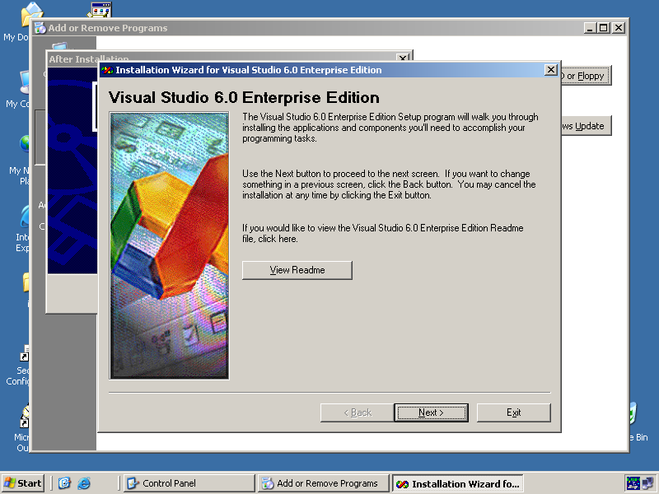

2)

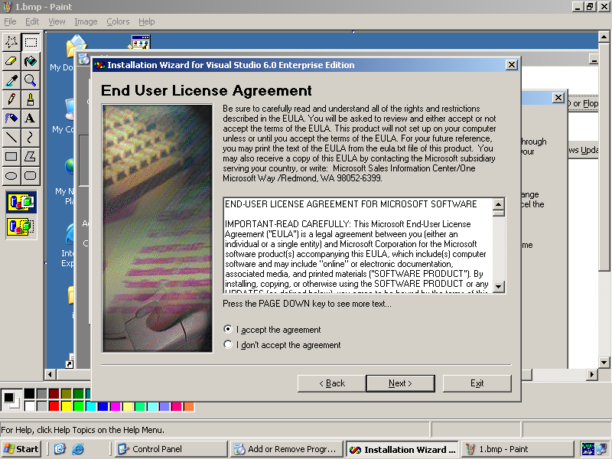

3)

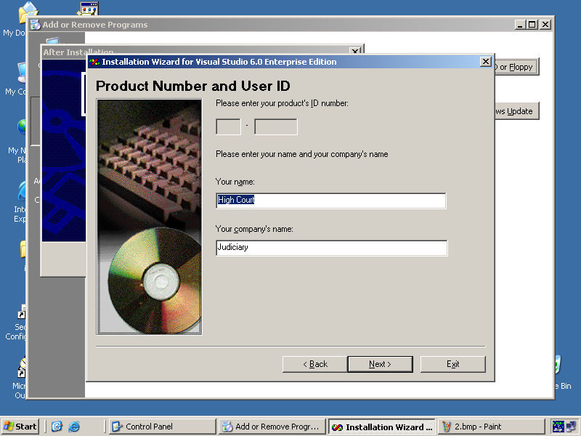

4)

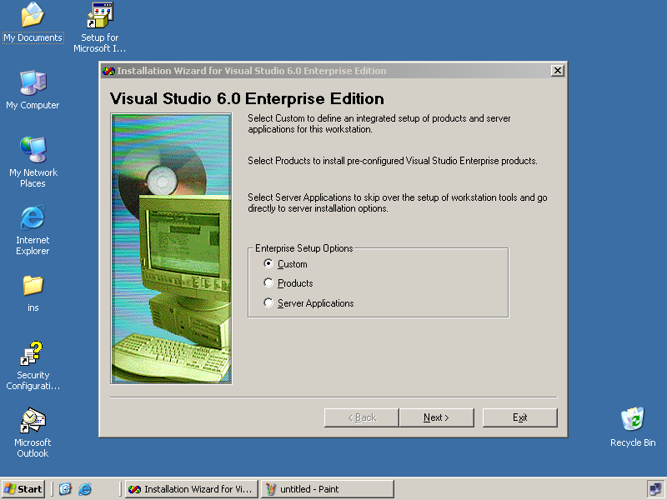

5)
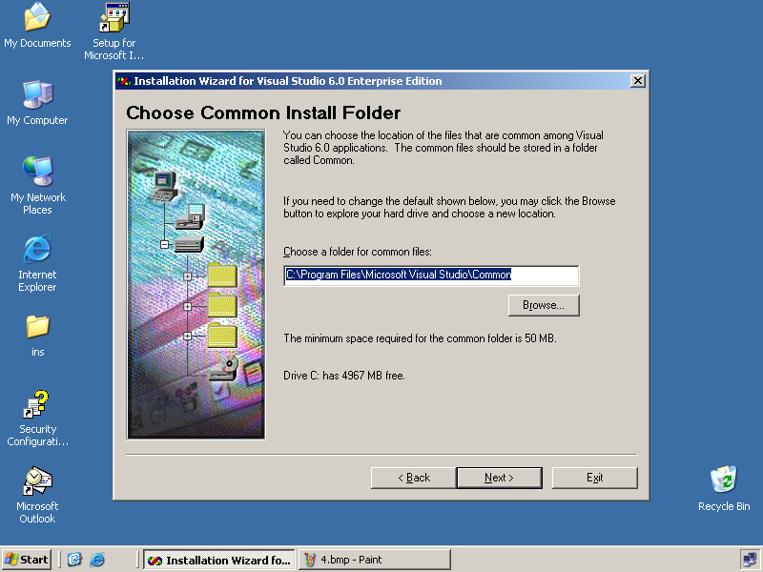

6)

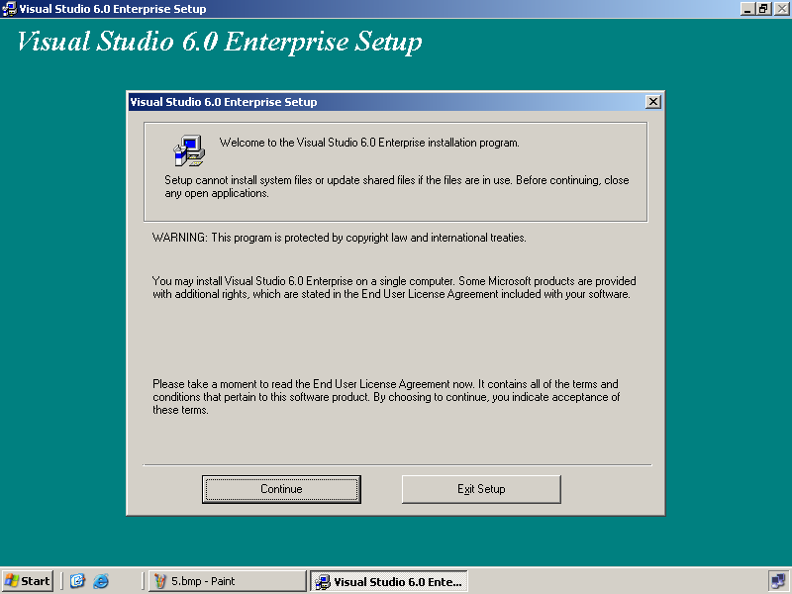
7)

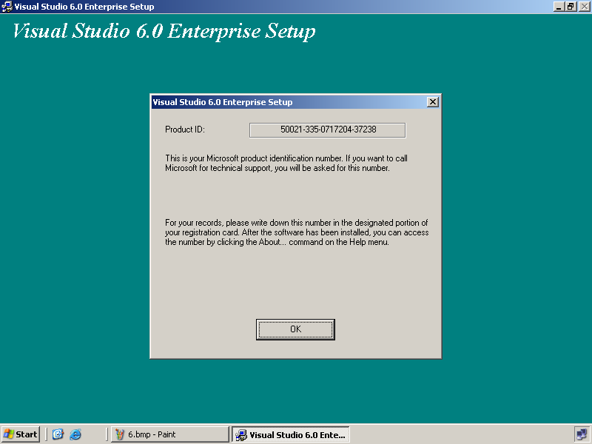

8)

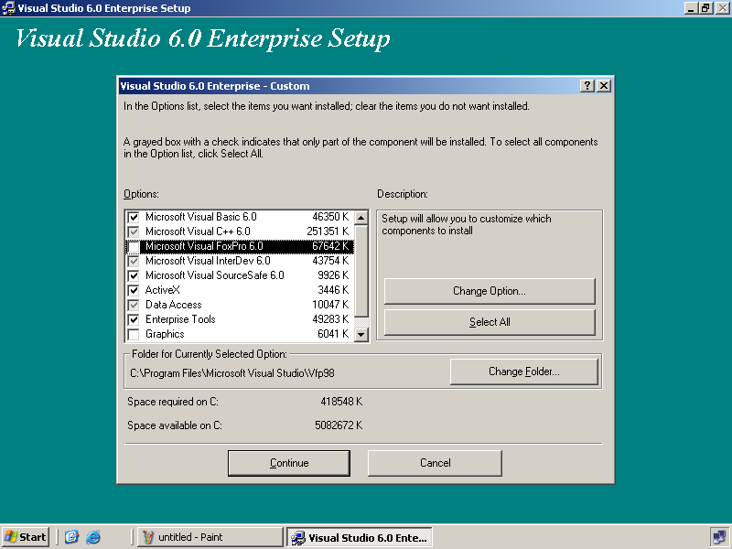

9)

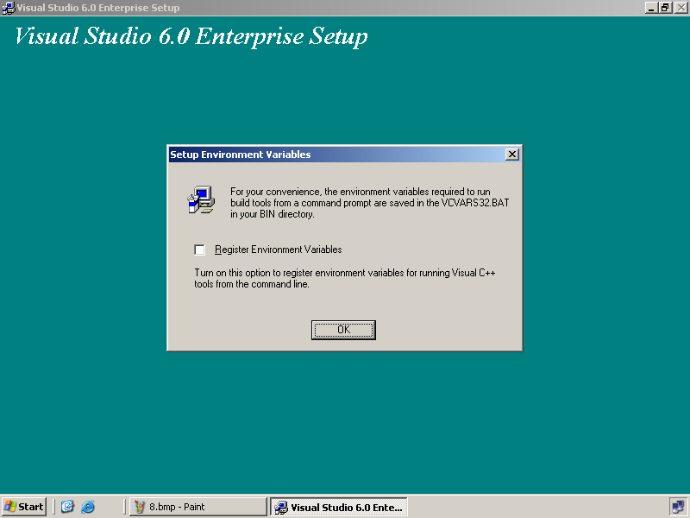

10)

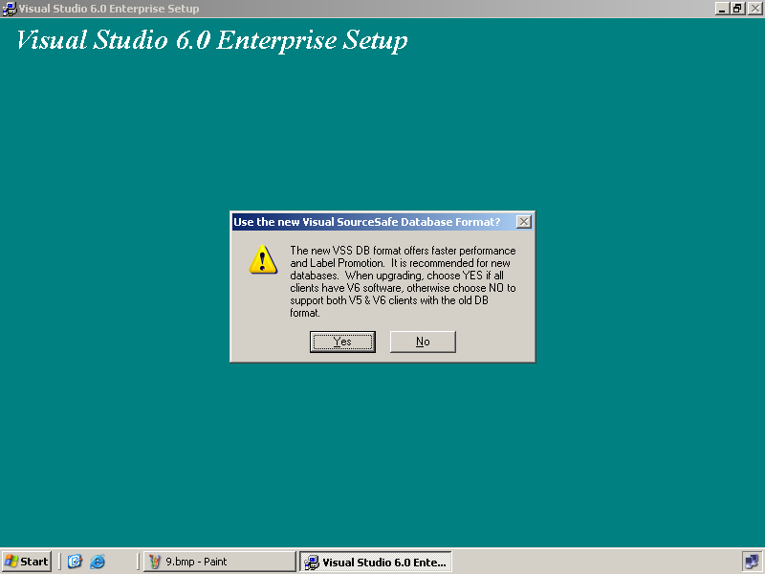

11)

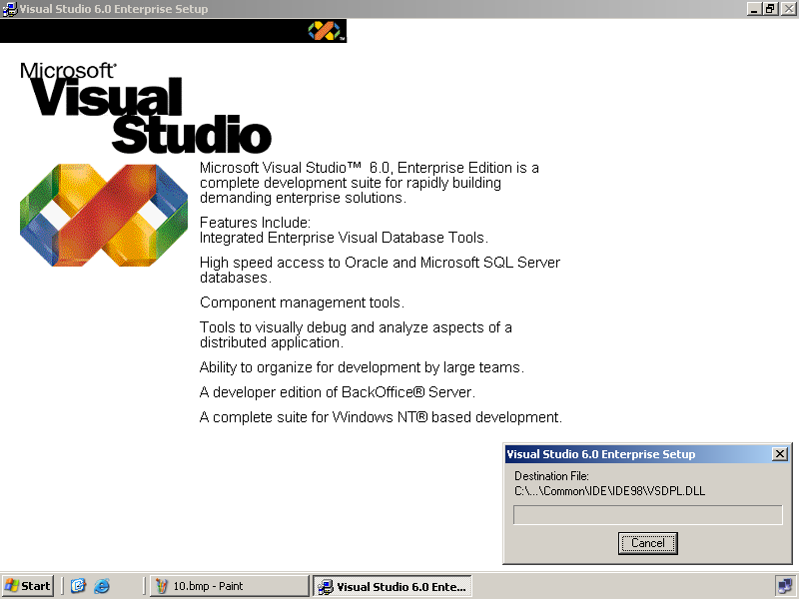

12)

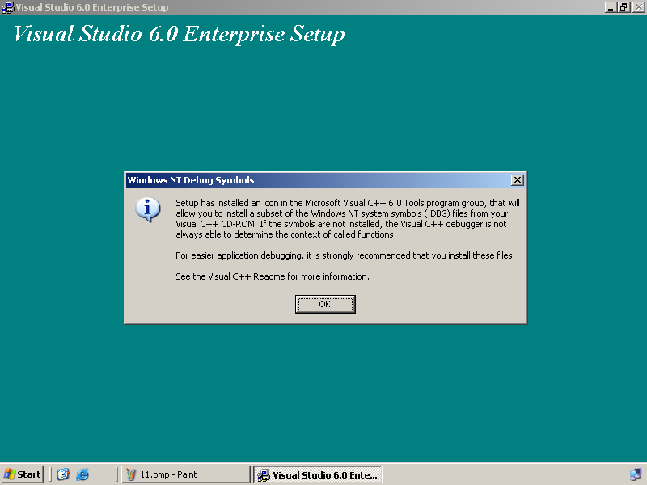

13)

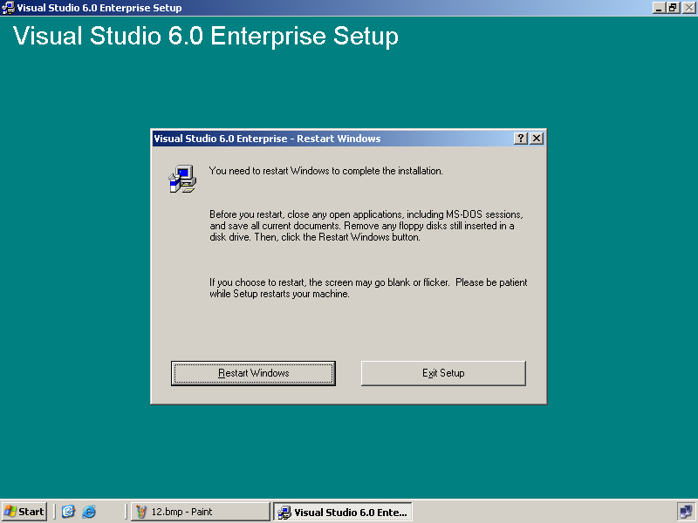

14)

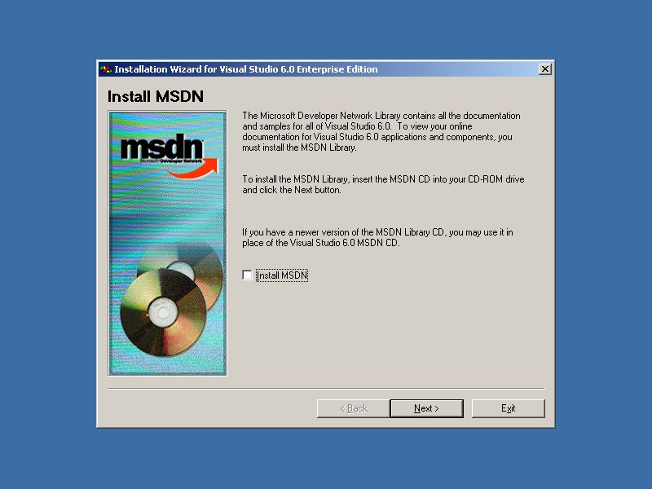
Creating user

Generally in every court there will be 5 Clients.
We need to create 5 Users
- JO1 Presiding Officer (Judge)
- JO1-CH Court Hall Typist
- JO1-CO1 Stenographer
- JO1-CO2 Admin Sheristedar
- JO1-CO3 Accounts Sheristedar

If it has 2 courts than we should have 5 more users
- JO2
- JO2-CH
- JO2-CO1
- JO2-CO2
- JO2-CO3

Start
->Programs
->Administrative Tools
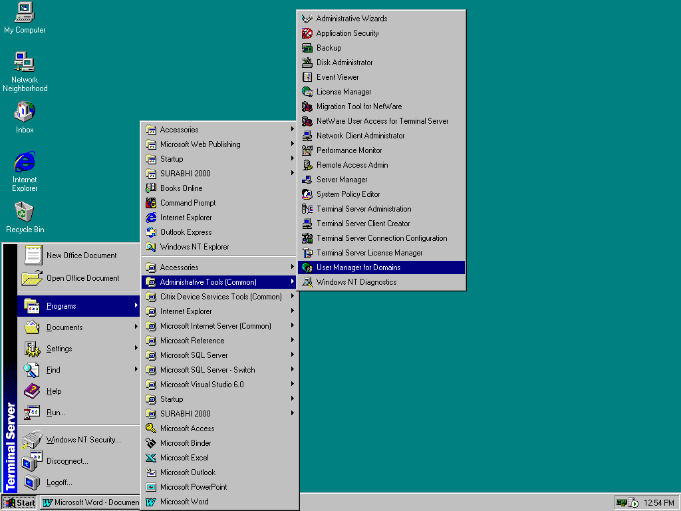
->UserManager for Domains

Later a window will open
->Click on users menu
->Select new users from dropdown menu
-> A window will open. Here give user name and click on Add.

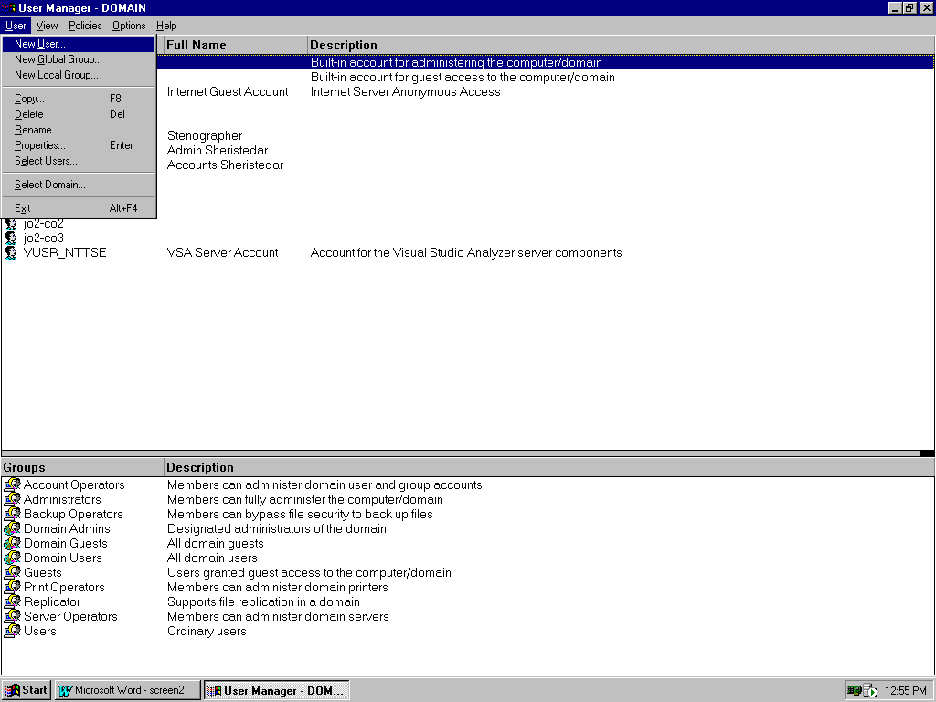
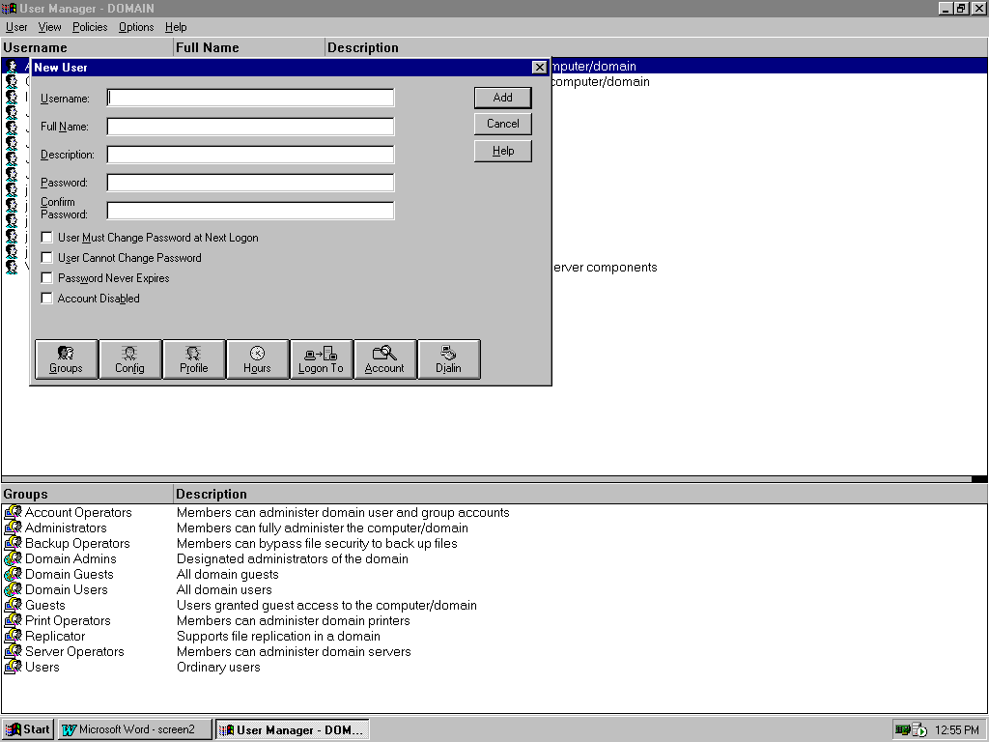
Finally the users created will be listed

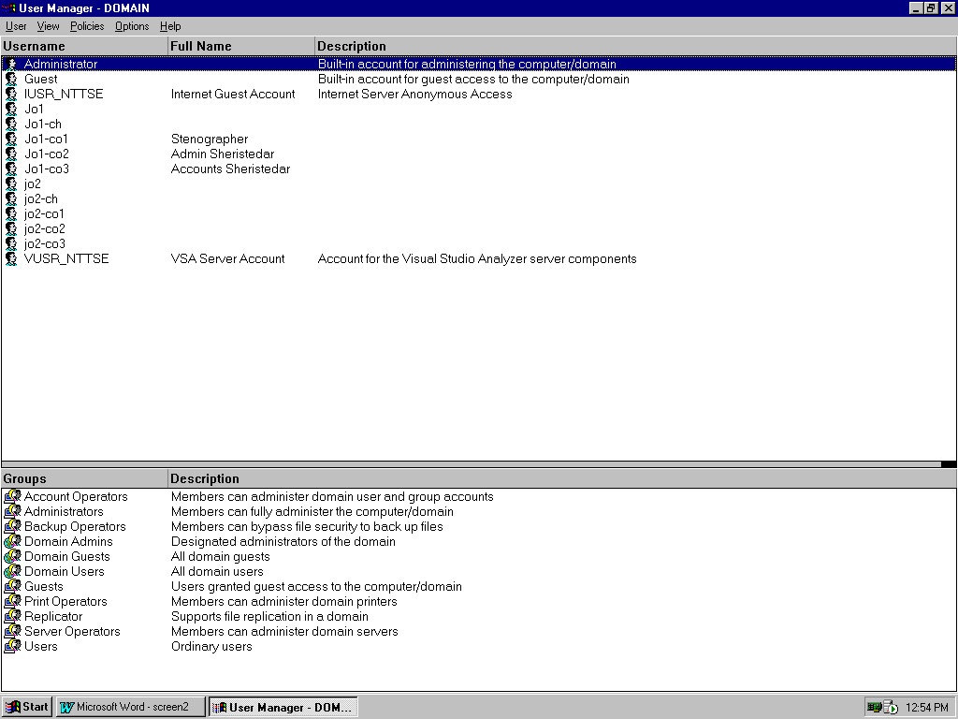

Set Path

Right click (or double-click) on user
->Select properties
->A Window will pop up here select config
->Another window will pop up here uncheck the checkbox initial program later give the specified path of Start.exe and click OK (To be done for all users)

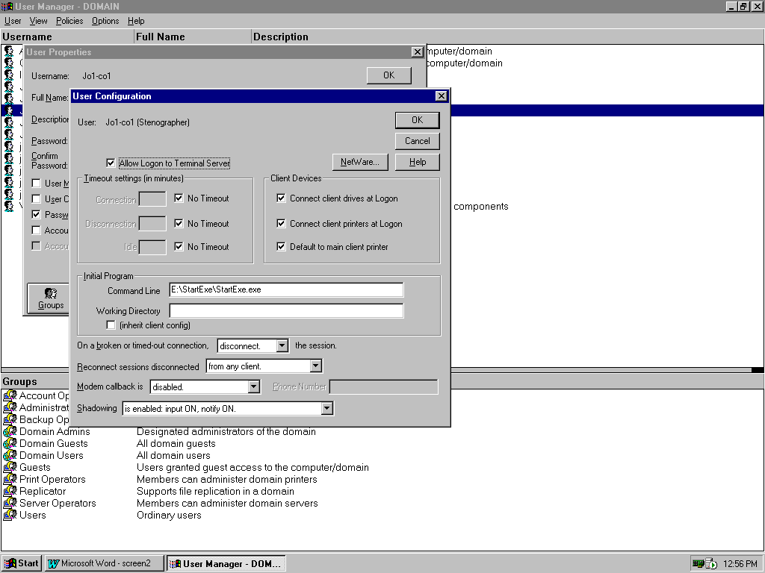
Set Permissions

Permission must be added to respective User only (if user name is not displayed in list then click on show user tab)

Now login from thin client giving the specified username and password
It must list only 4
-> Document Management
->Litigation Management System
->MS Excel
->Close

Open MS WORD using Document Management

->Word will be displayed and later click on view menu and select page layout

->Later select Tools menu and later select options as shown below

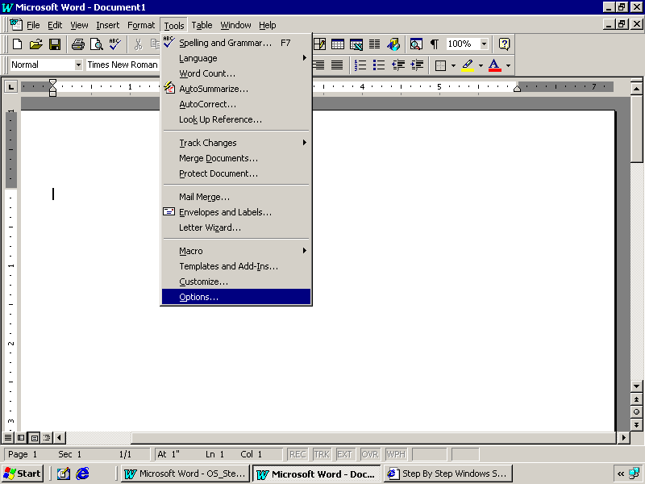

->A window will pop up as show below and now select File Location Tab in this
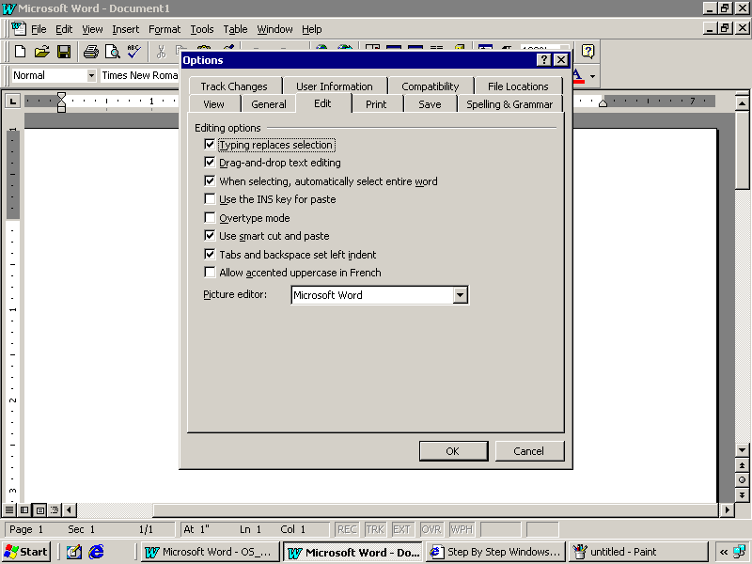

->After selecting file locations Tab a window will open select the File Type as Document and click on Modify
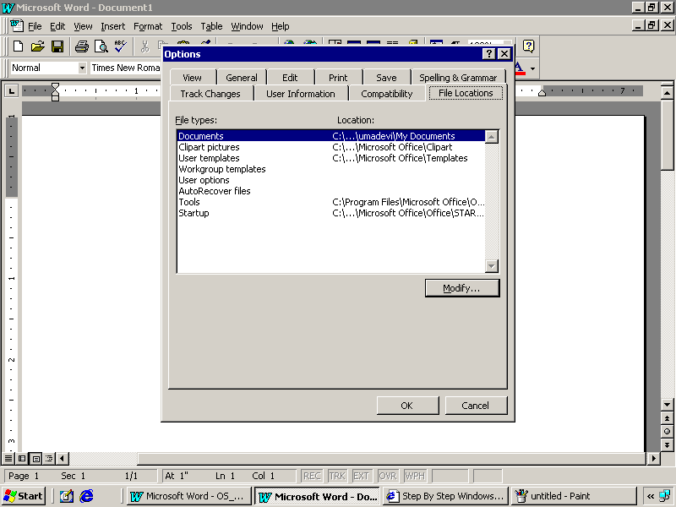

->After modify is clicked following window is diaplayed here select the path of the user and click ok .

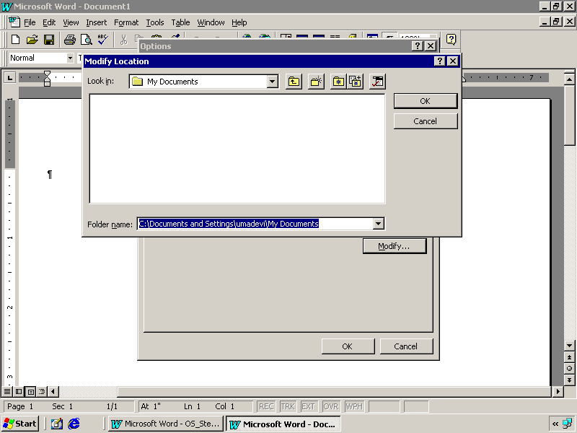

Select MS EXCEL
->Click on tools menu and later click on options as show below

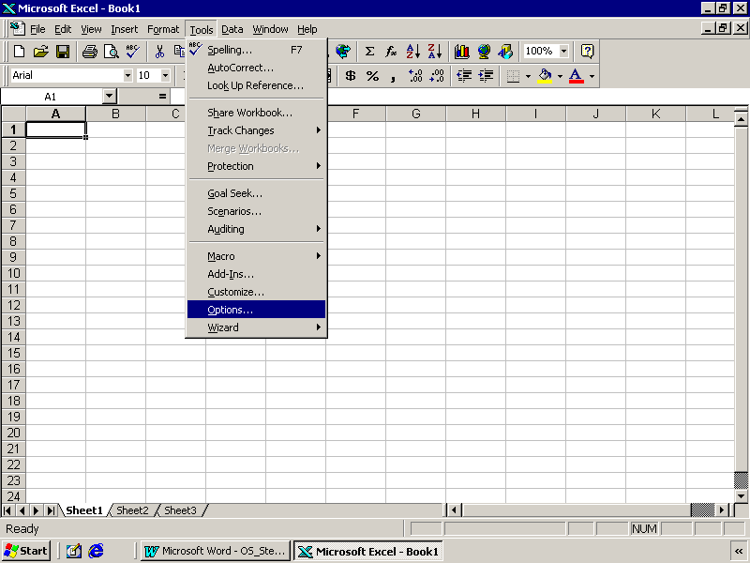
->After selecting options the window will appear. Select General tab here

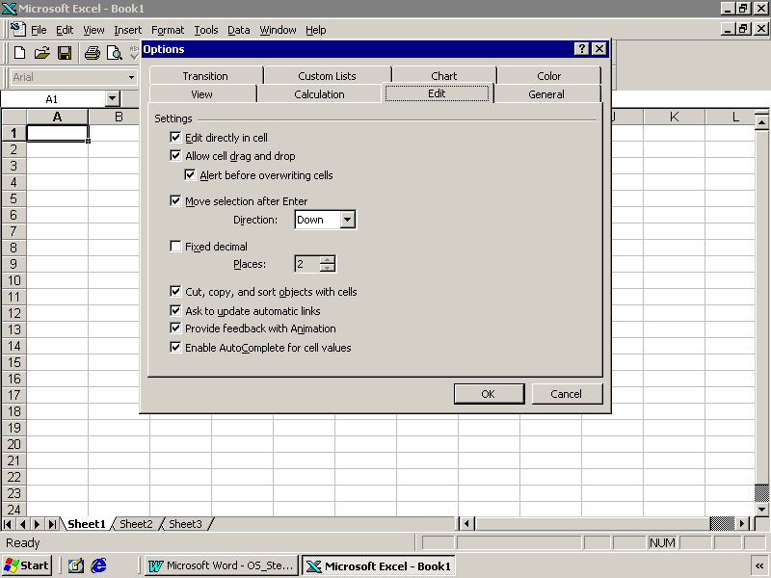

- After selecting general tab, a window will pop up as show below. Specify the Default fie location as per MS Word and click ok
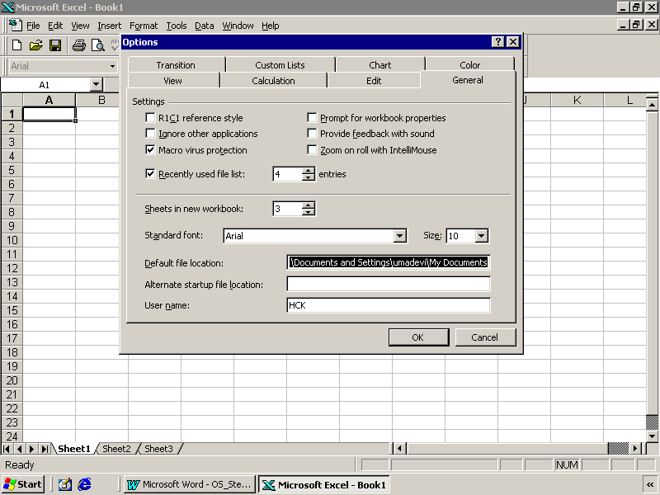

TAPE BACKUP
Select start->programs->Administrative tools->Backup as shown below
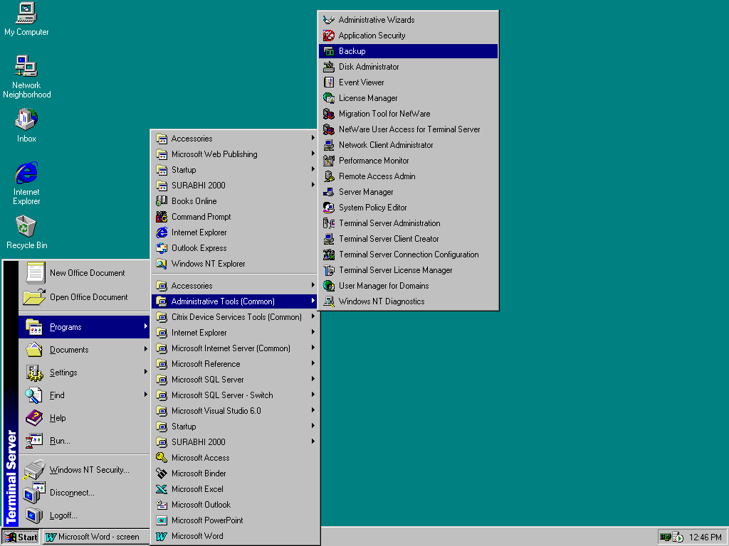

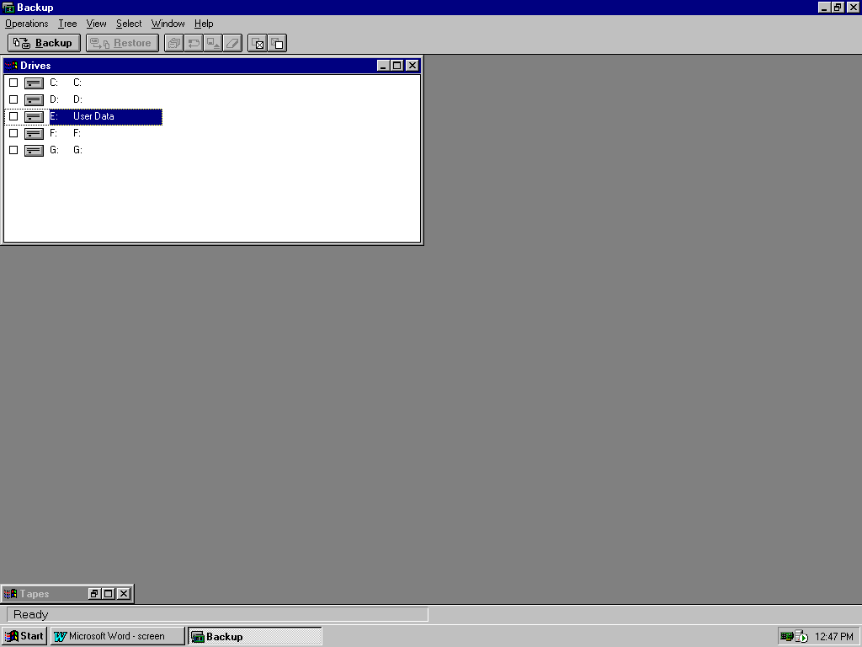
After selecting backup a window will open as shown below. Here select the specified drive to take backup
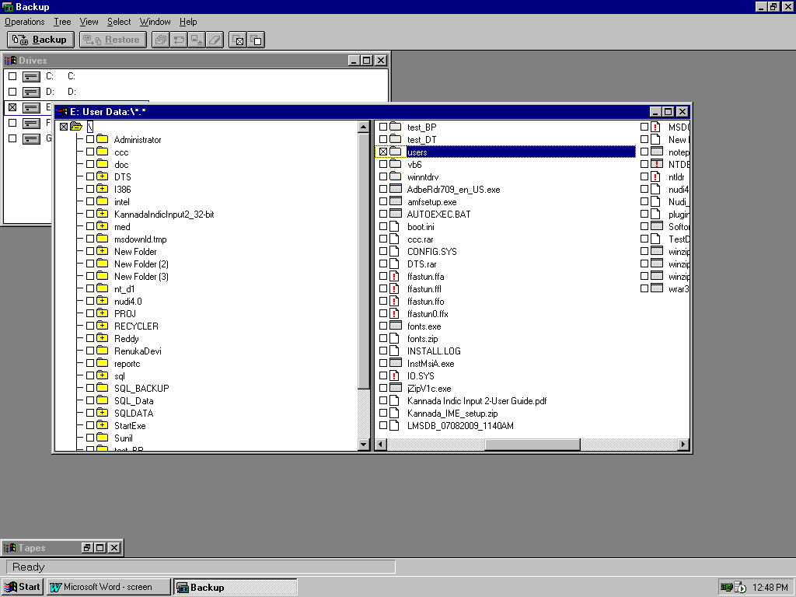
Restoring from Tape
If need to restore from tape then maximize the Tapes which is at bottom as shown in above figure then the following window shall appear.
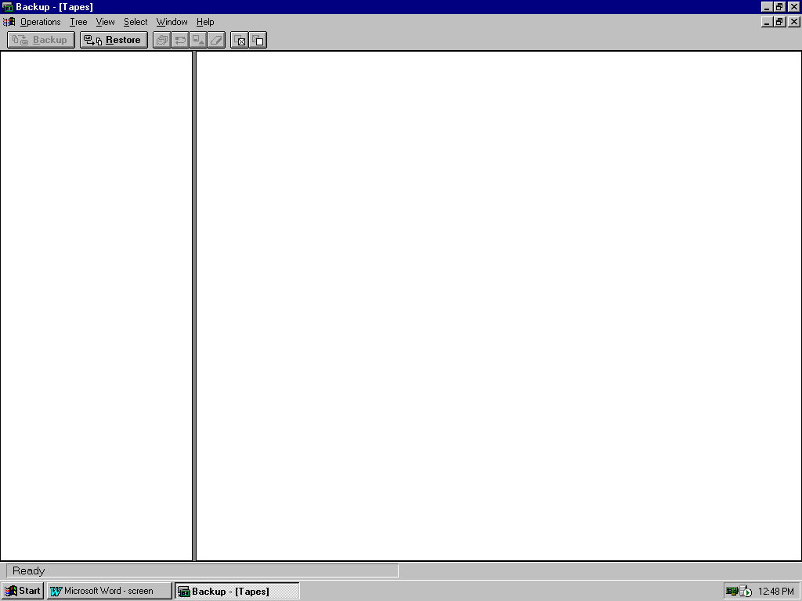
SQL BACKUP

Start->Programs->Microsoft SQL Server->Enterprise Manager
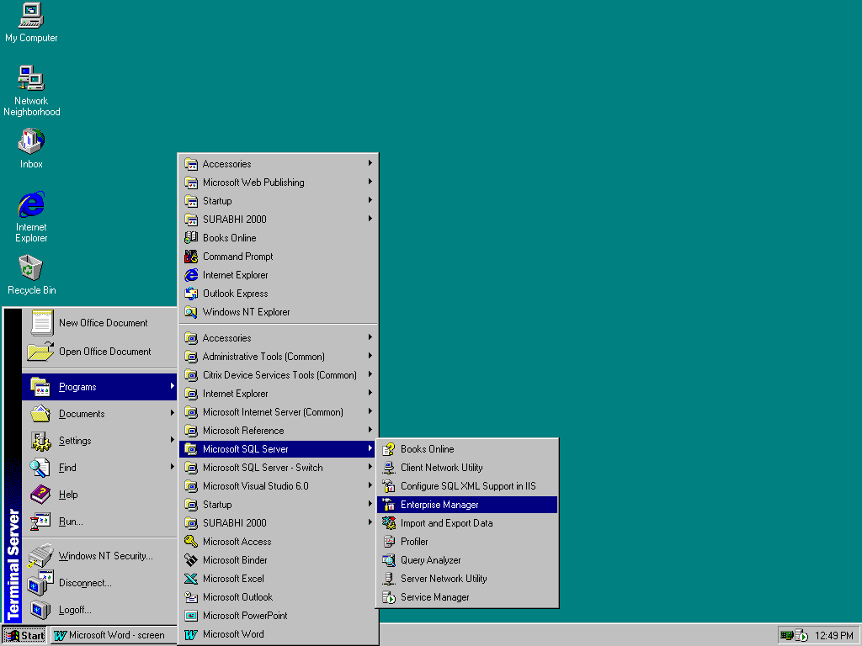

A window will open later
Right click on selected database
->All Tasks
->Backup Database

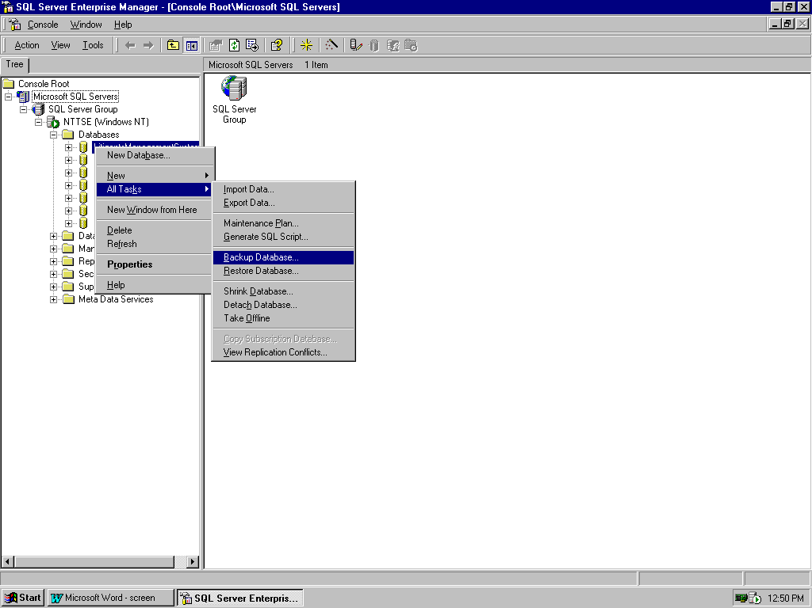

On selectin Backup Database a window will appear as shown below.Here specify the path and click on ok.This file generated is taken as backup in tape drive

